Celera Motion Unveils New Ultra-Lightweight Inductive Encoder

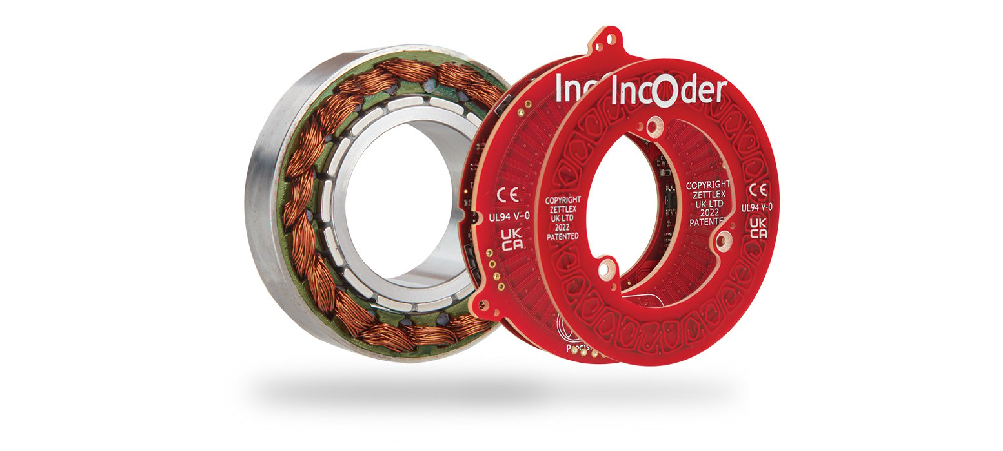
Everight Position, a US distributor for Celera Motion and Zettlex, is excited to announce a new version of the lightweight IncOder CORE inductive encoder series.
The new 70mm O.D. IncOder CORE is a frameless, non-contact, position feedback sensor featuring all the robust and reliable position sensing technology of a traditional housed IncOder in an unpackaged, stacked printed circuit board (PCB) kit that reduces OEM system mass and costs.
“In most surgical and industrial robotic applications customers need the reliability and performance associated with IncOders, but don’t need the rugged housing of the traditional units,” said Jarrod Orszulak, Applications Engineer at Everight Position. “Expanding the encoder range with the 70mm O.D. size enables a larger bore, offers improved measurement performance.”
IncOder CORE is well suited for integration into actuators and rotary joints. The position sensor offers superior robust benefits to magnetic encoder solutions, with improved measurement performance and greater immunity to external magnetic fields. IncOder CORE utilizes a unique field-proven inductive technique, delivering highly repeatable, reliable, temperature-stable performance.
IncOder CORE is designed for segments including medical and surgical robotics, industrial and collaborative robotic systems, AGV, AMR, rotary actuators, and gimbals. The sensor can be configured to a range of sizes, absolute digital output, resolution, and connector orientations with options for customization available.
Features of IncOder CORE include:
- Up to 20 bits output resolution
- Up to 125” (0.035°) accuracy, guaranteed within installation tolerances
- Absolute digital output (BiSS-C, SSI, SPI, Asynchronous Serial)
- Low mass, frameless rotor and stator
- Now available in Ø70mm O.D/ Ø30mm I.D and Ø44mm O.D./ Ø10mm I.D. size options
- Compact screw mount features.
- No calibration
Benefits of IncOder CORE include:
- Frameless, compact design for reduced weight and design envelope
- Repeatable, accurate and high-resolution absolute position feedback
- Large bore and low axial height for use in rotary actuators
- Insensitive to contamination, providing robust position measurement
- Easy-to-install: No precision installation tolerances, providing simple installation
- No calibration, reducing OEM production time and cost
- Economical price for reduced system cost
- Customization and additional sizes for optimized system design
- Prototype units stocked for fast delivery.
For more information, visit: page on evrtp.com to be populated
About Everight Position
Founded in 2008, Everight Position is a specifying distributor for rotary encoders as well as linear, tilt and liquid level sensors. Working with world-class sensor manufacturers such as Netzer Precision, Positek Ltd, POSITAL, Gill Sensor and Controls and Zettlex Ltd, Everight combines the best hardware with one-on-one application support. By striving to understand a specific customer’s needs, Everight Position helps lead customers to the right solution, and furthermore works with vendors to customize products when necessary, in an economical manner while maintaining practical lead times.
Further information
Jarrod Orszulak
Everight Position Technologies Corporation
29 Bala Ave, Ste 124
Bala Cynwyd, PA 19004
jarrod@evrtp.com , 856-727-9500, www.evrtp.com

